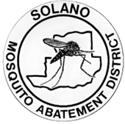
Press Release
October 9, 2025
West Nile Virus Detection
On October 8, 2025, the Solano County Mosquito Abatement District (SCMAD) detected West Nile virus in mosquitoes off Robben Road in Dixon.
Residents in the area are advised to take necessary precautions to avoid mosquito bites, especially if planning to spend time outdoors in and around the detection area. Recommended measures include using EPA-registered repellents containing DEET, Picaridin, Oil of Lemon Eucalyptus, or IR3535, and wearing long-sleeved shirts and pants during peak mosquito activity hours. SCMAD technicians are conducting targeted control efforts in the affected area to reduce the mosquito population. We will continue to monitor this area.
The map below highlights the detection area of concern.
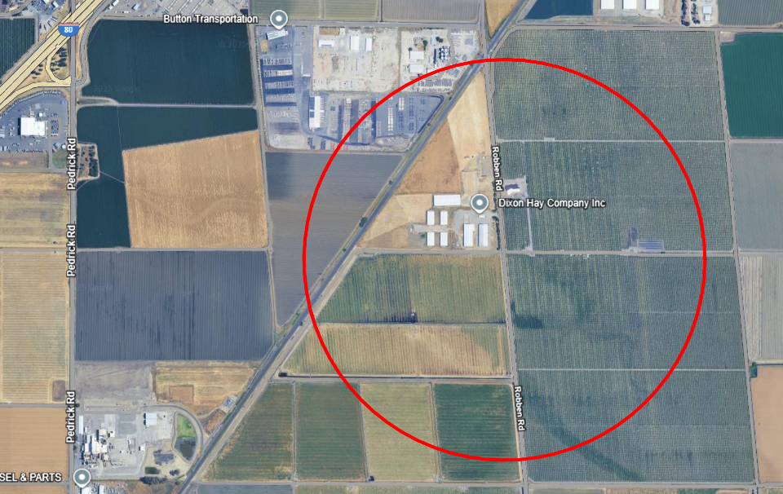
Use the link below to access map pictured above.
https://earth.google.com/earth/d/19i77l7IEfN7solovFgOJw65QvqwAubyb?usp=sharing

West Nile Virus Information You Need to Know
How It Spreads
- A mosquito becomes infected by biting a bird with West Nile virus, then spreads it by biting a person.
Symptoms
- Most people show no symptoms.
- Some may develop a fever, headaches, or body aches.
- Severe cases can lead to hospitalization or, in rare instances, death.
- If symptoms occur, contact your healthcare provider.
Who’s Most at Risk
- Older adults
- Individuals with chronic conditions such as diabetes, high blood pressure, cancer, or kidney disease
Preventing West Nile Virus
Eliminate Standing Water
- Empty flowerpots, buckets, pet dishes, and old tires.
- Clean bird baths and pet bowls weekly.
- Avoid over-watering lawns and gardens.
Fix Leaks
- Repair broken sprinkler heads and leaky faucets.
Secure Your Home
- Check window and door screens for holes and proper fit.
Maintain Pools & Ponds
- Keep pools clean and circulating.
- Request free mosquito fish for neglected pools, ponds, or water troughs.

About The District
The Solano County Mosquito Abatement District has served the community since 1930, covering over 900 square miles of both incorporated and unincorporated areas of Solano County.
SCMAD works to protect public health by reducing the risk of mosquito-borne diseases like West Nile virus. Through surveillance, public education, and environmentally responsible treatments, the District helps keep mosquito populations under control and improves quality of life for Solano County residents.
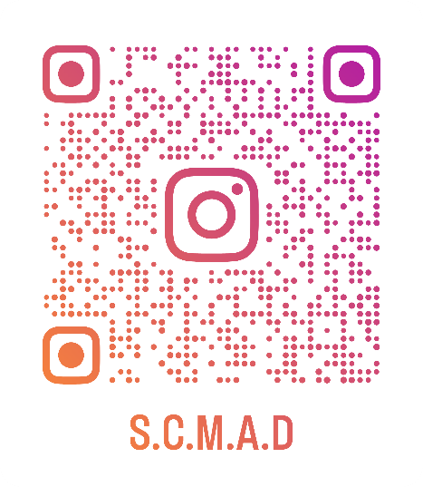
Contact us at
707-437-1116
solmad@solanomosquito.com
Website www.solanomosquito.com
Sign up for email notifications at
www.solanomosquito.com/stay-in-touch
Follow us on Instagram

